HECTOR+ @ AGATA@PRESPEC measurement campaign at AGATA@PRESPEC
March 2014

The present document lists the BaF and LaBr crystals position for HECTOR and HECTOR+ arrays, extracted from the detectors external surface measurements taken in December 2013 at GSI with Leica AT401 Laster Tracker (P. Morrall, R. Cash and F. Tomasi)
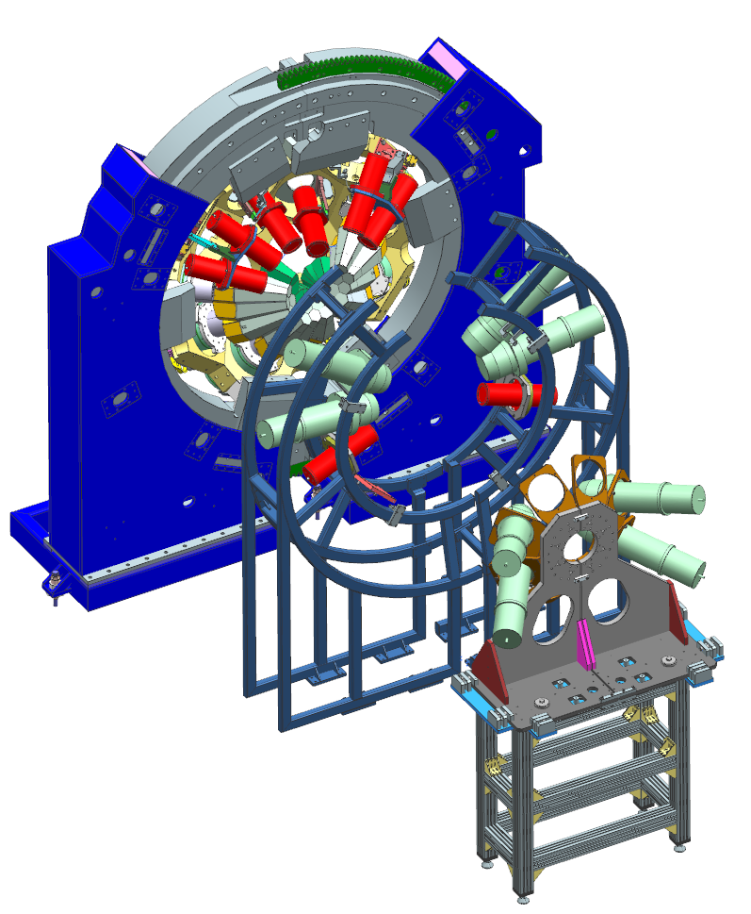
Measurement precision is rounded around few tenth of mm.
LaBr-7
LaBr-10
LaBr-9
LaBr-6
LaBr-5
LaBr-4
LaBr-3

LaBr-8
Baf 8
Baf 5
Baf 3
Baf 6
Baf 2
Baf 7
Baf 4
Baf 1

Table gives radius r and angle θ determined from the crystal front face (back face) centre to the theoretical target.
The angle for the analysis should be “Average angle”.
The difference angle gives an estimate of the tilting of the detector axis in respect to the target-back-face angle. (A positive/ negative sign means the detector is looking upstream/downstream from the target).
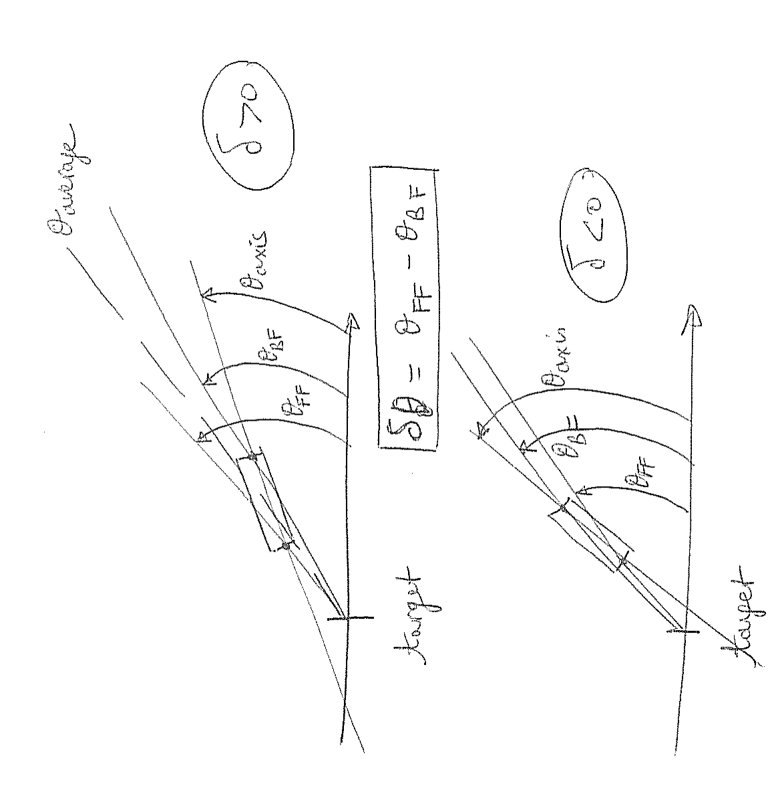

The largest difference angle of 1.1° means the centre of the front face is displaced by 6mm as compare to the target-back face centre direction.
The length of the detectors are BaF: 177mm, LaBr: 213.3mm.

AGATA | r front-f. | Av. r | Angle front-f. | Angle back-f. | Average angle | Diff. angle | diff 2012-2014
LABR_3 | 394.71 | 39cm | 68.1 | 68.0 | 68.1 | 0,12
LABR_4 | 394.90 | 39cm | 67.6 | 67.5 | 67.6 | 0,08
LABR_5 | 385.85 | 39cm | 67.6 | 67.6 | 67.6 | -0,02
LABR_6 | 385.81 | 39cm | 67.7 | 67.7 | 67.7 | 0,03
LABR_10 | 391.52 | 39cm | 23.2 | 22.4 | 22.8 | 0,83
LABR_9 | 391.52 | 39cm | 22.5 | 21.8 | 21.7 | -0,26
MINIBALL | r front-f.
LABR_7 | 365.86 | 36cm | 96.1 | 95.5 | 95.7 | 0,52 | Right MB  shifted 7mm  further to right
BAF_7 | 362.50 | 36cm | 96.6 | 96.1 | 96.4 | 0,56 | Right MB  shifted 7mm  further to right
BAF_6 | 364.25 | 36cm | 96.7 | 96.1 | 96.4 | 0,58 | Right MB  shifted 7mm  further to right
BAF_5 | 352.40 | 36cm | 98.0 | 96.8 | 97.4 | 1.13 | Left MB  shifted 3mm  to right
BAF_8 | 357.12 | 36cm | 97.1 | 96.4 | 96.8 | 0,68 | Left MB  shifted 3mm  to right
LABR_8 | 364.10 | 36cm | 96.5 | 95.8 | 96.1 | 0,70 | Left MB  shifted 3mm  to right
HECTOR TABLE | r front-f.
BAF_3 | 357.58 | 35.7cm | 142.1 | 142.1 | 142.1 | 0,04
BAF_2 | 357.58 | 35.7cm | 142.0 | 142.0 | 142.0 | 0,06
BAF_1 | 357.40 | 35.7cm | 142.4 | 142.3 | 142.4 | 0,11
BAF_4 | 356.93 | 35.7cm | 142.5 | 142.4 | 142.4 | 0,09

Following drawings describe the layout of each type of detectors:
- for LABR:
the length of the detector is taken on average as 213.3mm, including a 5mm glass window on the PMT side. A 1mm rubber is inserted between the crystal and the case.
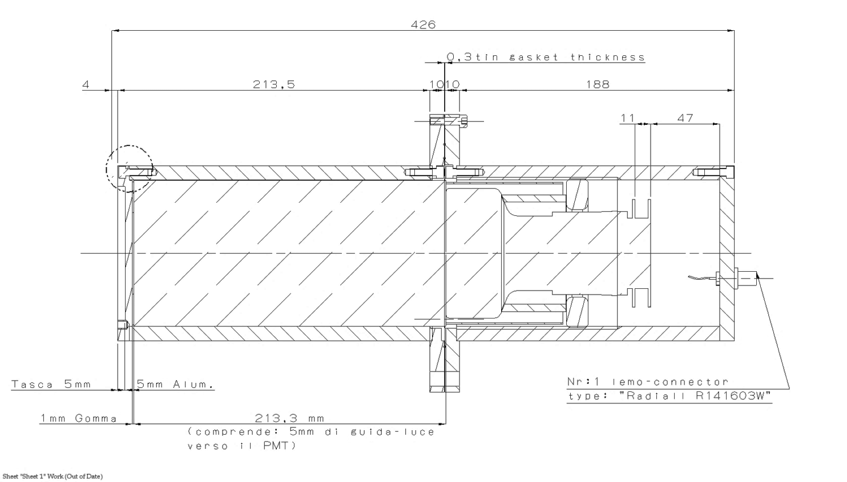

- for BaF:
the length of the detector is taken as 177mm. (There is no light guide between BaF and PMT)
the amount of rubber between crystal and case is variable (about 1 to 4mm) and not inserted in the
following drawing.
The distance between endcap and petal resulting from drawing is 218mm (=20+44+160-6) and is coherent with measurement of 217.64mm on BaFDET3 (assumed to be similar for all BaF type detectors). 

